1. What are the top 10 highest rated movies?
SELECT TOP 10
Moive_Name,
Rating,
Votes
FROM imdb_data
WHERE TRY_CAST(Rating AS FLOAT) IS NOT NULL
ORDER BY TRY_CAST(Rating AS FLOAT) DESC;
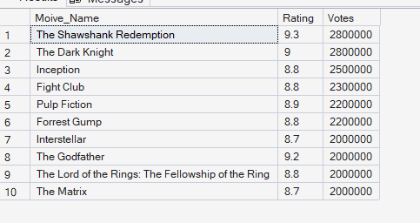

2. What are the top 10 most voted movies?
SELECT TOP 10
Moive_Name,
Rating,
Votes
FROM imdb_data
ORDER BY votes DESC;
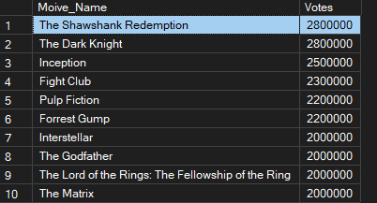

4. Which genre has the highest average rating?
SELECT TOP 10
Genre,
ROUND(AVG(Rating), 2) AS avg_rating,
COUNT(*) AS total_movies
FROM movie_genres
GROUP BY Genre
ORDER BY avg_rating DESC;

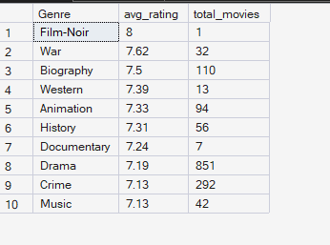

5. Genre with most movies:
SELECT TOP 10
Genre,
COUNT(*) AS total_movies
FROM movie_genres
GROUP BY Genre
ORDER BY total_movies DESC;
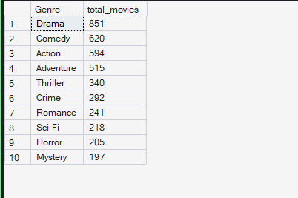

6. Which year had the highest average rating?
SELECT TOP 10
Year,
ROUND(AVG(Rating), 2) AS avg_rating,
COUNT(*) AS total_movies
FROM imdb_data
WHERE Year IS NOT NULL
GROUP BY Year
ORDER BY avg_rating DESC;
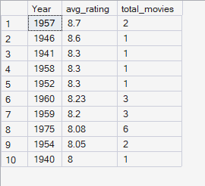

7. Which director has made the most movies?
SELECT TOP 10
Director,
COUNT(*) AS total_movies
FROM imdb_data
WHERE Director IS NOT NULL AND Director != ''
GROUP BY Director
ORDER BY total_movies DESC;

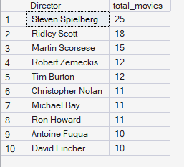

8. Which director has the highest average rating? 3+ movies only
SELECT TOP 10
Director,
ROUND(AVG(Rating), 2) AS avg_rating,
COUNT(*) AS total_movies
FROM imdb_data
WHERE Director IS NOT NULL AND Director != ''
GROUP BY Director
HAVING COUNT(*) >= 3
ORDER BY avg_rating DESC;

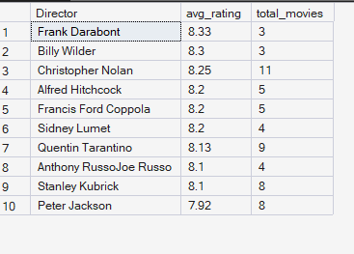

9. Which PG Rating gets the best audience ratings?
SELECT
PG_Rating,
ROUND(AVG(Rating), 2) AS avg_rating,
COUNT(*) AS total_movies
FROM imdb_data
WHERE PG_Rating IS NOT NULL AND PG_Rating != ''
GROUP BY PG_Rating
ORDER BY avg_rating DESC;
